# Biomass Clipping on Established Transects

**Project Objectives**

1. Determine how much forage remains at the end of the dormant season.
2. Determine how this varies based on prairie dog abundance, soil type, disturbance history, and other factors.
3. Interpret data to determine implications for fall/winter grazing management and prairie dog management.

**Overview of Tasks for Each Transect**

|  |  |  |  |
| --- | --- | --- | --- |
| **Category** | **Tasks** | **Datasheets** | **Equipment** |
| Understory Veg | Metadata, shrubs and clipping | Clipping | ½ x 1 m frame, clippers, buckets, sharpies, bags, rulers, staplers, 50m transect tape, pin, compass, GPS unit, maps. |
| Prairie dogs | Activity of Prairie Dog Burrows | Clipping | 50m transect tape, 4m long rope (can use Robel Pole) |
| Understory Veg | Visual Obstruction | Robel Pole | 50m transect tape, Robel Pole |

1. ***Locating transects***
2. **Background**

Most of the clipping points (C, L, and E points) are part of a larger project in which bird and vegetation data are being collected along broad-scale transects. These broad-scale transects are named C1-C10, L1-L10, and E1-E60. Along each broad-scale transect, there are 5-8 points separated by 250m at which vegetation and bird data have been collected. Points along the transect C1 are named C1.1, C1.2, C1.3, etc. We are clipping biomass at a subset of these points. Below are details on how the biomass clipping transects were cited relative to the larger bird transects. **For Spring 2023 clipping, we are also providing coordinates specific to the biomass clipping transects (see below), but you many need the background information below in order to tell which way to place the clipping quadrat along the transect.**

* 1. **For C, L, and E transects:** Pace out 8 meters perpendicular to the established vegetation transect in the same heading as the main (bird) transect (see figures below). Run a transect tape parallel to the established vegetation transect to establish a 30m transect. Use a compass and the transect list to determine the given vegetation transect heading.
  2. For **BMZ points** pace 8 m 90° (due East) and run transects 0° (North).
  3. **For A and Other transects:** pacing is not required. Coordinates are provided for the biomass clipping transect’s start and end locations.

*Transect Description:*

**NOTE:** We are clipping at 2-3 of the main (bird) transect points, NOT all of them.

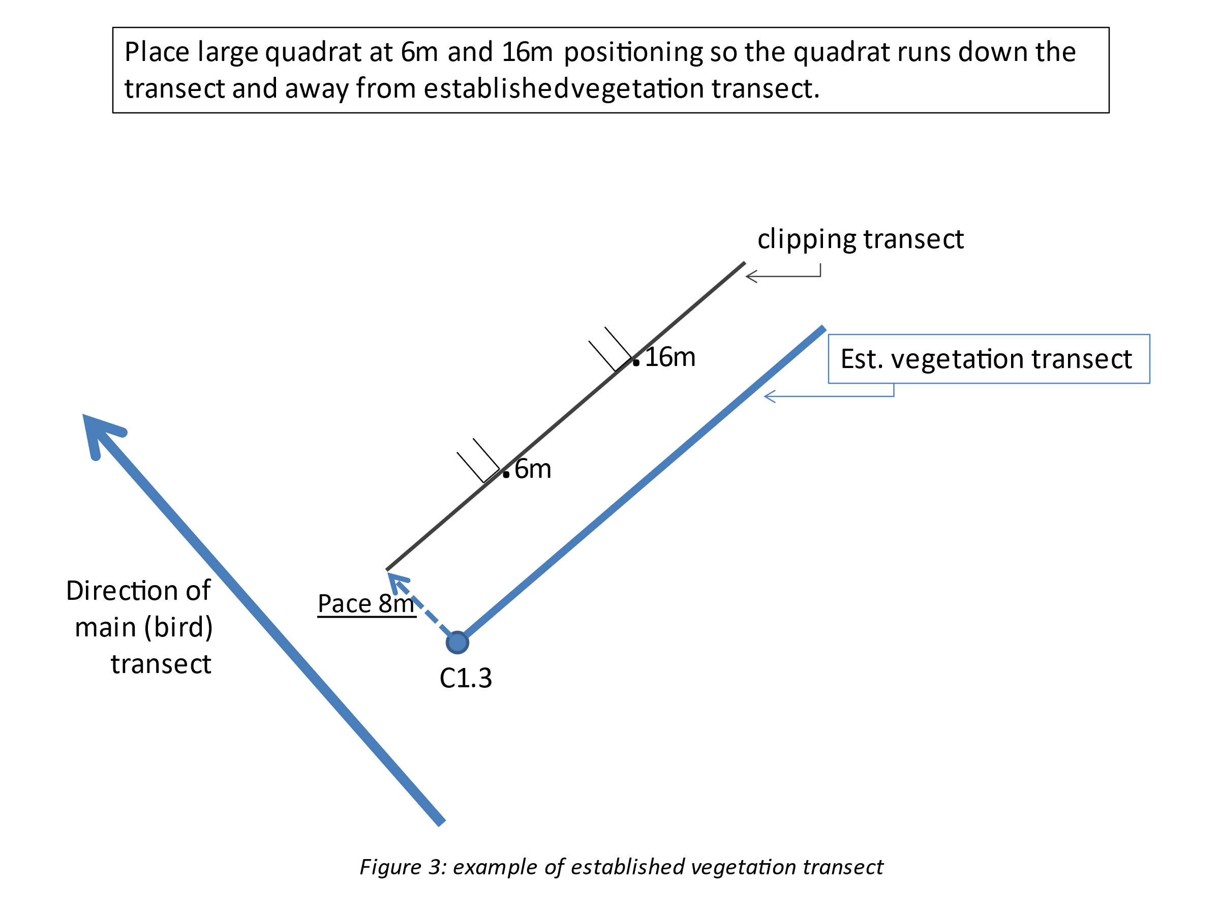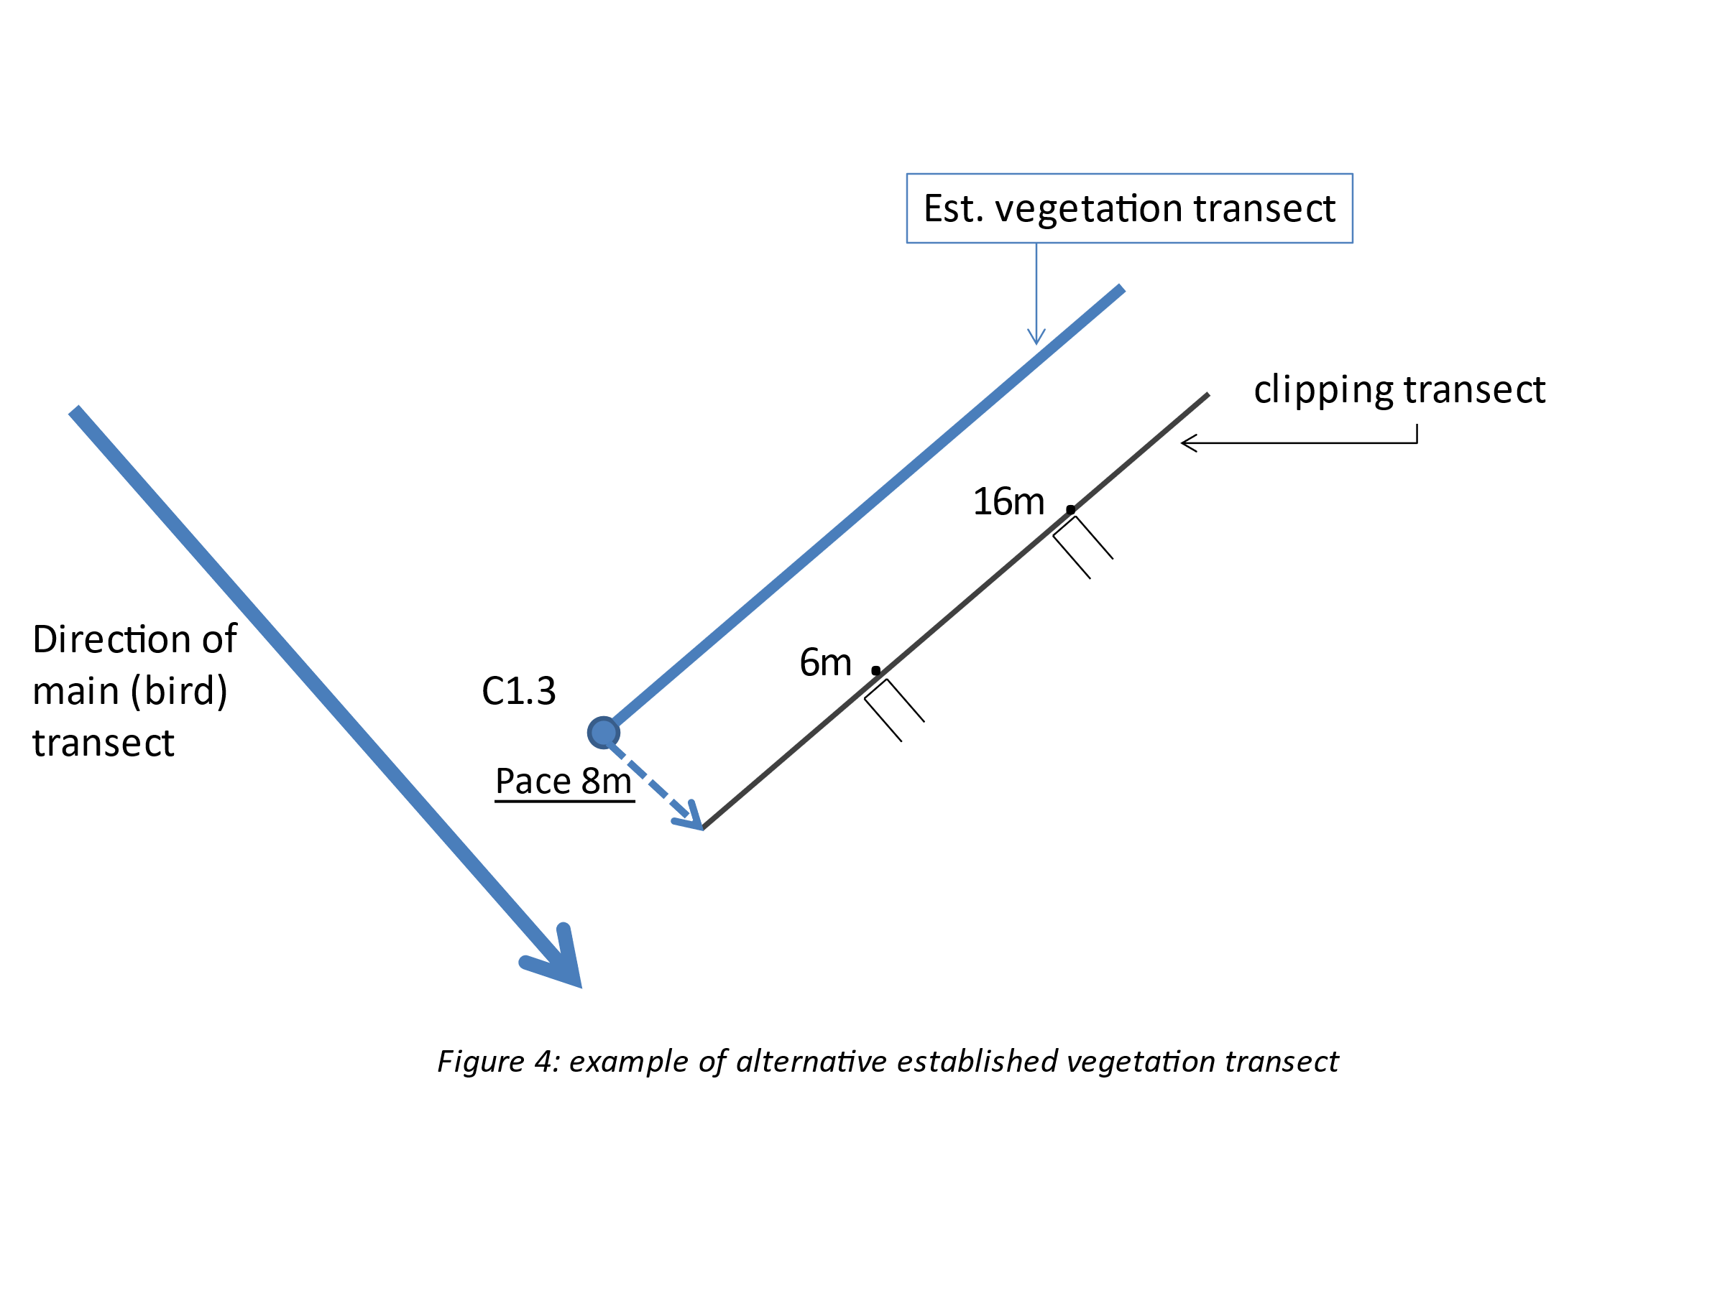

1. **Spring 2023 transect citing:** For Spring 2023 sampling, in addition to providing the coordinates for points as described above, we are providing the specific coordinates for locations clipped this past summer. First, use the coordinate list to determine if the transect is an A, E, C, L, BMZ, or Other point.
   * 1. ***For A, E, C, L, and BMZ transects:*** Use a high-quality GPS unit to locate the 11m and 21m plots that were clipped this past summer. Pull a 30m tape so that these plots again fall at 11 and 21 m. If the plots cannot be relocated, use the GPS unit to place the transect as close as possible to the previous location, or use the point coordinates to re-cite the transect as described above.
     2. ***For “Other” transects:***These are locations near long-term studies where we clip biomass each summer. We have provided coordinates for locations near, but not within, the long-term study plots. Use the coordinate list to establish the 0m (start) end of the transect. Pull the tape due north for 30m.
2. ***Clipping***

**Clipping locations throughout time**

|  |  |
| --- | --- |
| **Year** | **Distance (m)** |
| 2017 | 10 & 20 m |
| 2018 | 5 & 15 m |
| 2019 | 8 & 18 m |
| 2020 | COVID: No sampling |
| 2021 | 13 & 23 m |
| 2022 | 11 & 21 m |
| Spring 2023 | 6 & 16 m |

* 1. At 6 m and 16 m along the transect, place the ½ x 1m quadrat on the side of the tape facing away from the established vegetation transect, in the same heading as the bird transect. This will vary depending on the main transect’s heading *(see figures 3 &4)*. For A, BMZ and Other transects, place the quadrat on the east side of the tape. Position the quadrat so its short edge is running **parallel to** the tape: 5.5 – 6 m and 15.5 – 16 m.
  2. Record GPS coordinates at the 6 m and 16 m points.
  3. Clip all herbaceous biomass **ROOTED** inside the quadrat by functional group. Functional group assignments are listed on the TB species list (excel file) and include: **BOGR/BUDA, other C4P, C3P, Brome, VUOC, Other annual grass, Annual/Biennial Forb, Perennial Forb, Sub-shrub, and Standing dead**. Clip all species of standing dead together as a single functional group and put in a separate bag (see below for how to define standing dead). Residual aboveground biomass should be <1 cm tall, but ensure that soil, litter, and roots are not bagged with the clipped biomass.
     1. In Thunder Basin C3 perennial grasses are predominant, with the most common C4 perennial grasses being BOGR, ARPU, SPCR, and SCPA.
     2. If a forb has “perennial” listed anywhere in the USDA plants classification, group it with perennial. Thus, species classified as annual/perennial, biennial/perennial, annual/biennial/perennial, and perennial should all be grouped with perennial. If it says annual or biennial or annual/biennial, group it with short-lived forbs.
     3. To be called a subshrub, the plant MUST be classified as either subshrub or forb/subshrub/shrub on USDA plants. Plants called forb/subshrub are grouped with forbs. Plants called subshrub/shrub are grouped with shrubs.

1. **Defining “live” vs. “standing dead” vs. litter.** In early spring of 2023, most plant tissue will be dead. If observers believe that the plant grew during the 2022 growing season, it is NOT standing dead and should be clipped by functional group. If the plant tissue was most likely dead at the beginning of the 2022 growing season, then it is either Standing Dead or litter. By early spring of 2023, there will likely be very little plant tissue remaining from the 2021 growing season. Standing dead tissue will likely look very grey, frayed, and decayed. If the plant tissue is not rooted in the ground, OR if it grew before the 2022 growing season and is now lying flat so that it is unclear whether or not it is still attached, then count it as litter and do not clip.
   1. For **shrubs** (ARTR, ATCA, CHVI, SAVE, KRLA, ARFI and ARCA) rooted inside the quadrat, **do not clip**, but take volume measurements (height, length, width, BD, % alive) for each individual and record on the datasheet. Exclude inflorescences from height measurements. If the shrub foliage is not symmetrical over the roots/trunk, include the trunk in the measurements even if this shrub base is not covered in foliage. In other words, measure the shrub length as the distance from where the far edge of the trunk comes out of the ground to the edge of the foliage. Measure the width as the widest part of foliage **perpendicular** to the length measurement. Measure the basal diameter as the longest distance between the outer edges of the two furthest trunks at ground level. Measure shrubs and basal diameter <10cm to the tenths place and anything >10cm to the ones place. Do not distinguish between live width/length and total width/length; record only total width/length.
   2. **Note % of each quadrat covered by shrub canopy (rooted + not rooted).**
   3. For **cacti**, **do not clip**, but count the number of cladodes rooted inside quadrat and record on datasheet. Do not include cactus flower buds as cladodes.
   4. Use a sharpie to **label Project (PDog Biomass), Transect, Distance, Date, and Functional Group on** **EVERY BAG.** Staple all bags per meter together for each transect and place in larger paper bag. **do not pack bags so tightly that they don’t dry properly. This will lead to mold growth. If necessary, divide samples between two bags. Label bags “1 of 2” and “2 of 2” if more than one bag is used for a single functional group. Place all bags clipped from a given transect and distance into a larger paper bag. Fold the opening over twice and staple.
   5. **Transect names:** It’s extremely important to correctly record which transect you are sampling, including both letters and numbers. Please double check prior to labelling as some of the transects share the same numbers, but are unique spatially. For example, we clip at both E9.1 and C9.1.
   6. **Dry all biomass at 60 degrees Celsius for 48 hours. Start drying within 12 hours of clipping.**
2. ***Prairie Dog Burrows***
   1. Count all prairie dog burrows at least partially within 4m of the 30m transect tape (8m-wide by 30m-long belt). Include a burrow if any part of the opening is within the belt.
   2. Record burrows by active or inactive. Consider a burrow active if fresh prairie dog scat is in the opening or within 0.5 m of it, or obvious fresh digging, tracks, and sightings. Fresh means droppings that are not dried hard and bleached white; fresh scat is greenish, black, or dark brown. Active burrows also generally have an open entrance (not covered by cobwebs or vegetation). Inactive burrows may have cobwebs completely covering the hole, or vegetation obstructing the hole. A close, detailed inspection of each burrow is not necessary or desirable. A maximum of 10 s / burrow is sufficient, and active burrows are often obvious at a glance.
   3. If the 8m belt does not represent the colony (for example, if there are many active burrows around but your belt has zero, or alternatively, if you have many burrows in your belt but there are relatively few in the area), extend by 8 meters on the side of the transect that is furthest from the previously established vegetation transect to create a 16m wide belt. Record any burrow observations and **be sure to** **note that you have changed the width of the belt**.
3. ***Visual Obstruction and Maximum Plant Height Readings (i.e. Robel Pole)***
4. Take readings from left and right directions, perpendicular to the transect and with the striped pole located 1m away from the tape. Start at 1 m along the tape, and take readings every 1 m to 20 m (20 readings on each side = 40 readings per transect).
5. First, record the highest band which has some type of vegetation in front of the pole (record in the “high” column). Be sure to not mark any plants that may look like they are in front of the robel pole but are actually behind. Use your co-workers to check if vegetation is in front of the pole or behind.
6. Second, record **the highest band** **for which some portion is visible but for which the band below it is completely obstructed** by the vegetation (record in the “low” column on datasheet). Also record the plant species causing the obstruction in the band associated with the “low” reading (see figure below).
7. If the wind is blowing record the first high and low you see on the pole. If the pole is in a hole/depression or behind a rise/mound with bare ground leave it where it is, and record 0 even if it might be at 3 on the pole. Make a note on the data sheet.
8. Adjust the location slightly if there is an obstruction caused by human infrastructure (e.g., a cage or fence).

